Sizewell C Notice to Mariners No 39 of 2026
Seabed Obstruction adjacent to Sizewell C Harbour

EA1N & EA2 Windfarm Works
Mariners are advised that:
Following the pipe pull works detailed in Notice to Mariners No 38 of 2026, an obstruction on the seabed has been reported by the contractor. The obstruction is reported to extend 4.0m above the seabed leaving a clearance below datum of 6.0m.

Position of Obstruction 52° 10’ 54N 001° 38’ 34E

The mooring spread close to the JUB Haven Seachallenger remains in place, and the obstruction lies within the mooring spread;

Mooring locations:
Mooring 1 52° 10. 97’N 001° 38.59’E
Mooring 2 52° 10. 97’N 001° 38.62’E
Mooring 3 52° 10. 96’N 001° 38.69’E
Mooring 4 52° 10. 87’N 001° 38.62’E
Mooring 5 52° 10. 90’N 001° 38.49’E
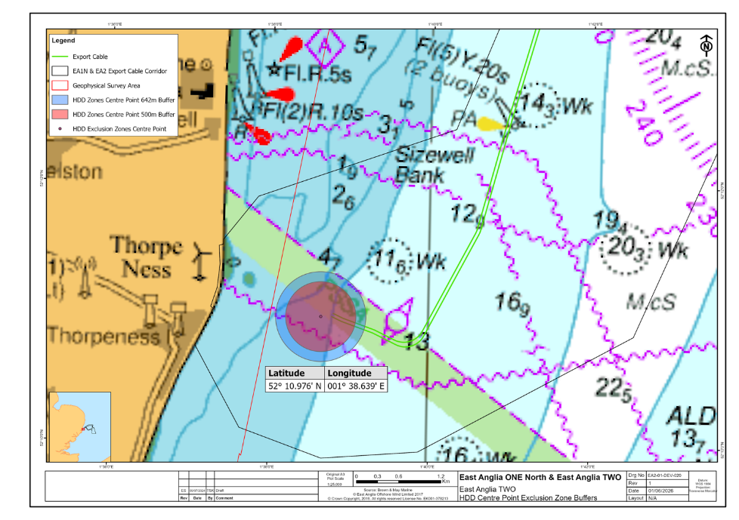

Figure 1: EA1N and EA2 Wind Farm Marine Works Location and JUB exclusion zone containing obstruction.

Neil Glendinning

SZC Harbour Master
Date: 06/10/2026
Any further enquiries regarding this Notice to Mariners should be directed to the ICCB project manager – Tony Lock at: t.lock@iccb.ie

Notices to Mariners in Force
No15 of 2024, No19 of 2024, No.10 of 2025, No.6 of 2026, No.7 of 2026 No.11 of 2026, No.12 of 2026, No.14 of 2026, No29 of 2026 & No.30 of 2026, No34 of 2026 & No36 of 2026

