Sizewell C Notice to Mariners No 33 of 2026
Pipe-pull Works adjacent to Sizewell C Harbour
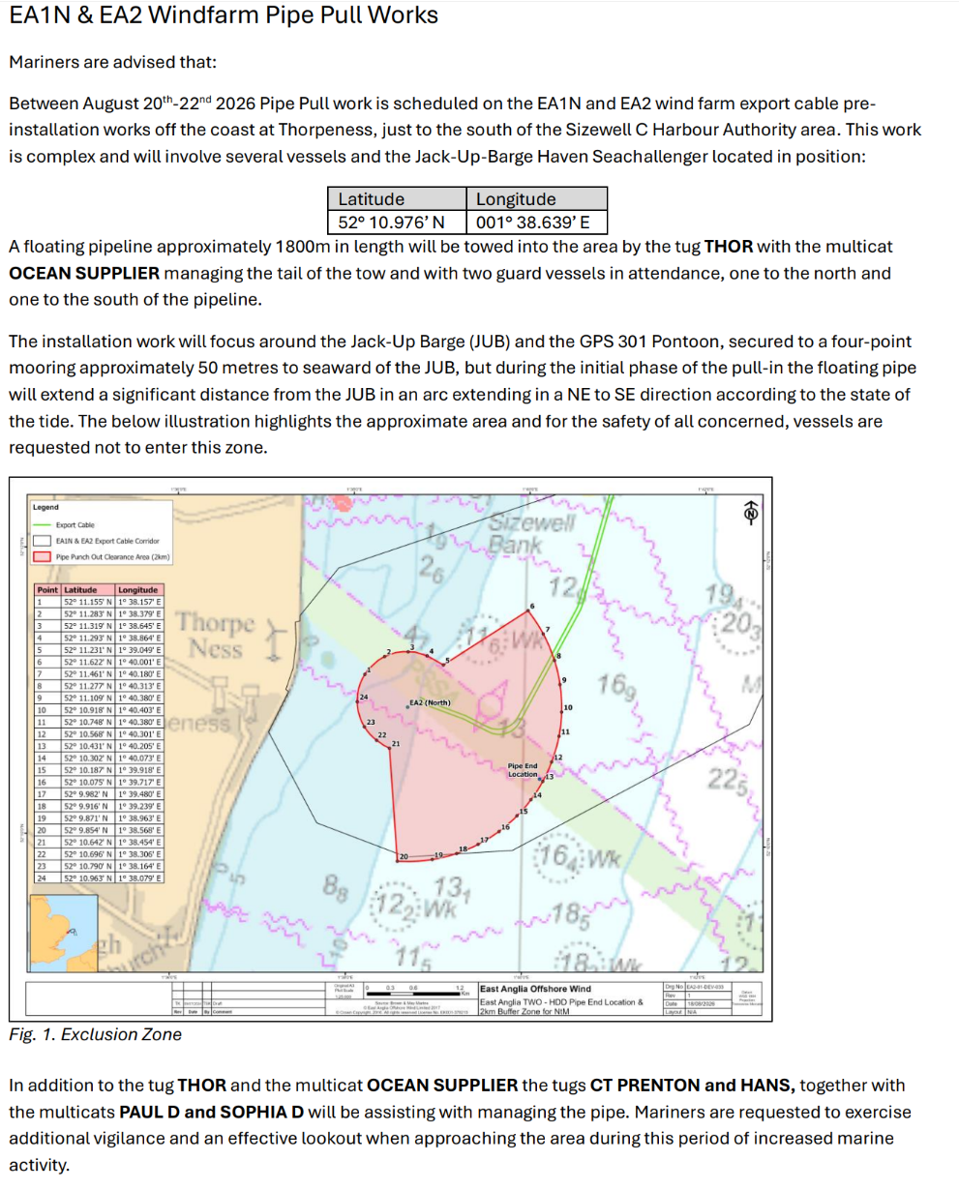

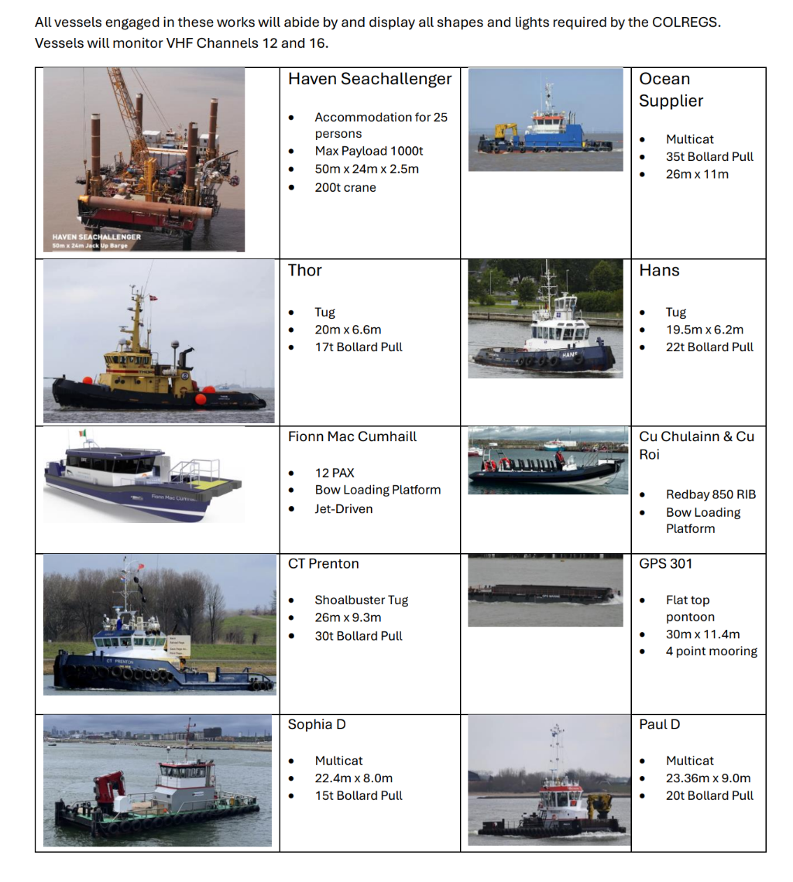
SZC Harbour Master
Date: 19/08/2026
Any further enquiries regarding this Notice to Mariners should be directed to the ICCB project manager – Tony Lock at: t.lock@iccb.ie

Notices to Mariners in Force
No15 of 2024, No19 of 2024, No.10 of 2025, No.6 of 2026, No.7 of 2026 No.11 of 2026, No.12 of 2026, No.14 of 2026, No26 of 2026, No29 of 2026, & No.30 of 2026

