SIZEWELL C LIMITED

COMPANY PROCEDURE

HARBOUR WORKS PROCEDURE

Procedure Code | 101453347
Revision | SZC 010
Date of Issue | 23-Oct-25
Next Review Date
Risk Categorisation | Highest Risk - 1 Year
Status | Fit For Use
Owner & Approver
Regulatory Approved | No
Usage Classification | Information Use
Requirement
CBL Number (if applicable)

© 2025 Published in the United Kingdom by Sizewell C Limited ("SZC"), 25 Copthall Avenue, London, EC2R 7BP. All rights reserved. No part of this publication may be reproduced or transmitted in any form or by any means, including photocopying and recording, without the written permission of the copyright holder SZC. All applications for permission should be addressed to SZC. Such written permission must also be obtained before any part of this publication is stored in a retrieval system of any nature. Requests for copies of this document should be referred to the Company Secretary, Sizewell C Limited, 25 Copthall Avenue, London, EC2R 7BP. The electronic copy is the current issue and printing this document uncontrolled.

CONTENTS

1 INTRODUCTION 3
1.1 Purpose 3
1.2 Scope 4
2 PROCESS FLOWCHART 5
3 INPUTS, OUTPUTS & ACTIVITIES 6
3.1 Procedure Inputs & Outputs 6
3.2 Harbour Works Review and Approval Process 7
4 SUPPORTING DOCUMENTATION 9
5 RECORDS REQUIREMENTS 9
6 RESOURCES 9
7 PEOPLE 9
8 REQUIREMENTS 9

Latest Revision

Revision | Description | By | Date
SZC 001 | Issued for review by harbour master | James Clark | 11-04-24
SZC 002 | Added requirement of signed cross-site modification form between SZB and SZC | Ed Rogers | 29-07-24
SZC 003 | Updates to procedure to allow for a 4-week consent timeframe for non-intrusive marine activity and refinement to process | Mark Blackwell | 06-09-24
SZC 004 | Added requirement for a member of the SZC Site Delivery Team to sign/authorise non-intrusive works (1.1.3 ii) | Mark Blackwell | 11-10-24
SZC 005 | Re-defined description of marine works which require approval, from intrusive and non-intrusive, to ‘obstructive’ or ‘non-obstructive’ respectively. | Mark Blackwell | 11-02-25
SZC 006 | Validation explanation added. | Mark Blackwell | 07-03-25
SZC 007 | Updates to procedure, contacts and formatting. | Ben Teague | 07-04-25
SZC 008 | Revision for SZC IMS | Kate Centnere | 22-07-25
SZC 009 | Revision for SZC IMS | Kate Centnere | 06-08-25
SZC 010 | Inclusion of Local Knowledge Endorsement (LKE) requirement | Mark Blackwell | 23-10-25

1 INTRODUCTION

1.1 Purpose

The Sizewell C (SZC) Harbour Authority is responsible for authorising marine works within the SZC Statutory Harbour Authority (SHA) area (see chartlet below) which may affect the safety of navigation (note that the SHA area extends beyond the Sizewell C Project Area (Development Consent Order (DCO) Red Line Boundary) to the north and south).

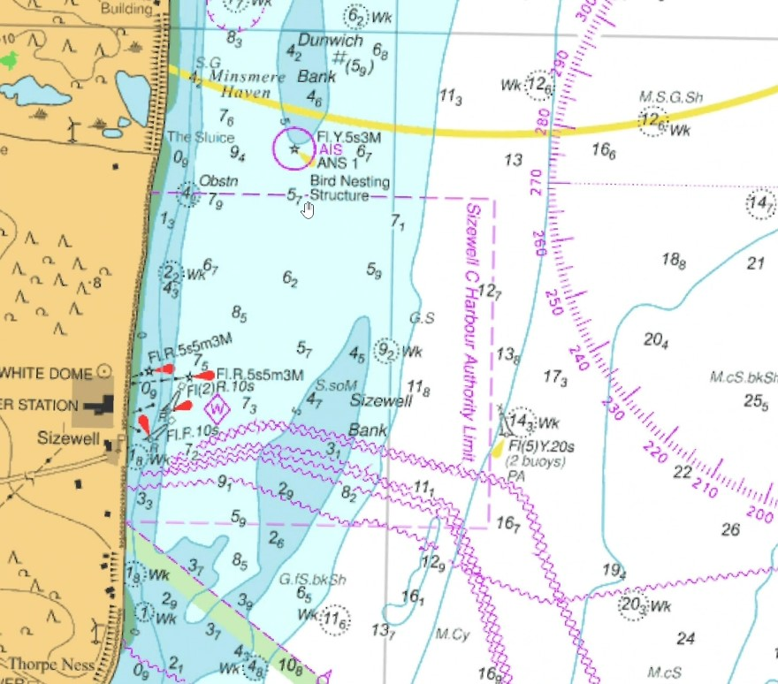

Examples of where navigation safety could be affected by marine works located within the SZC SHA area include, but are not limited to:

- Marine works involving the construction of any infrastructure (temporary or permanent by the SZC project or third parties) on or below the highest astronomical tide (HAT).

- Marine works involving vessel or drone-based surveying of any kind, including:

- Ground investigation surveys;
- Hydrography / Geophysical / Geotechnical surveys;
- Shoreline surveys on or below the HAT; and
- Sampling such as water sampling, grab sampling, etc.

- Marine works involving the deployment of any commercial craft or vessel or floating or fixed objects (such as mooring buoys, metocean buoys, tidal gauges, etc).

- Anchoring or ship-to-ship transfer of commercial vessels.

This list is not exhaustive and any commercial marine activity proposed within the SZC SHA area should be raised with the SZC SHA before any activities are conducted or carried out.

These responsibilities do not usually extend to developments either within the sea approaches to the SZC SHA area or on the foreshore above the HAT.

1.2 Scope

This Marine Works Application (MWA) process applies to all marine operations, both internal and external to the SZC Project, taking place within the SZC SHA. The MWA process is required to ensure that marine works are appropriately planned, managed and authorised by the SZC SHA and to ensure that navigational safety is maintained.

2 PROCESS FLOWCHART

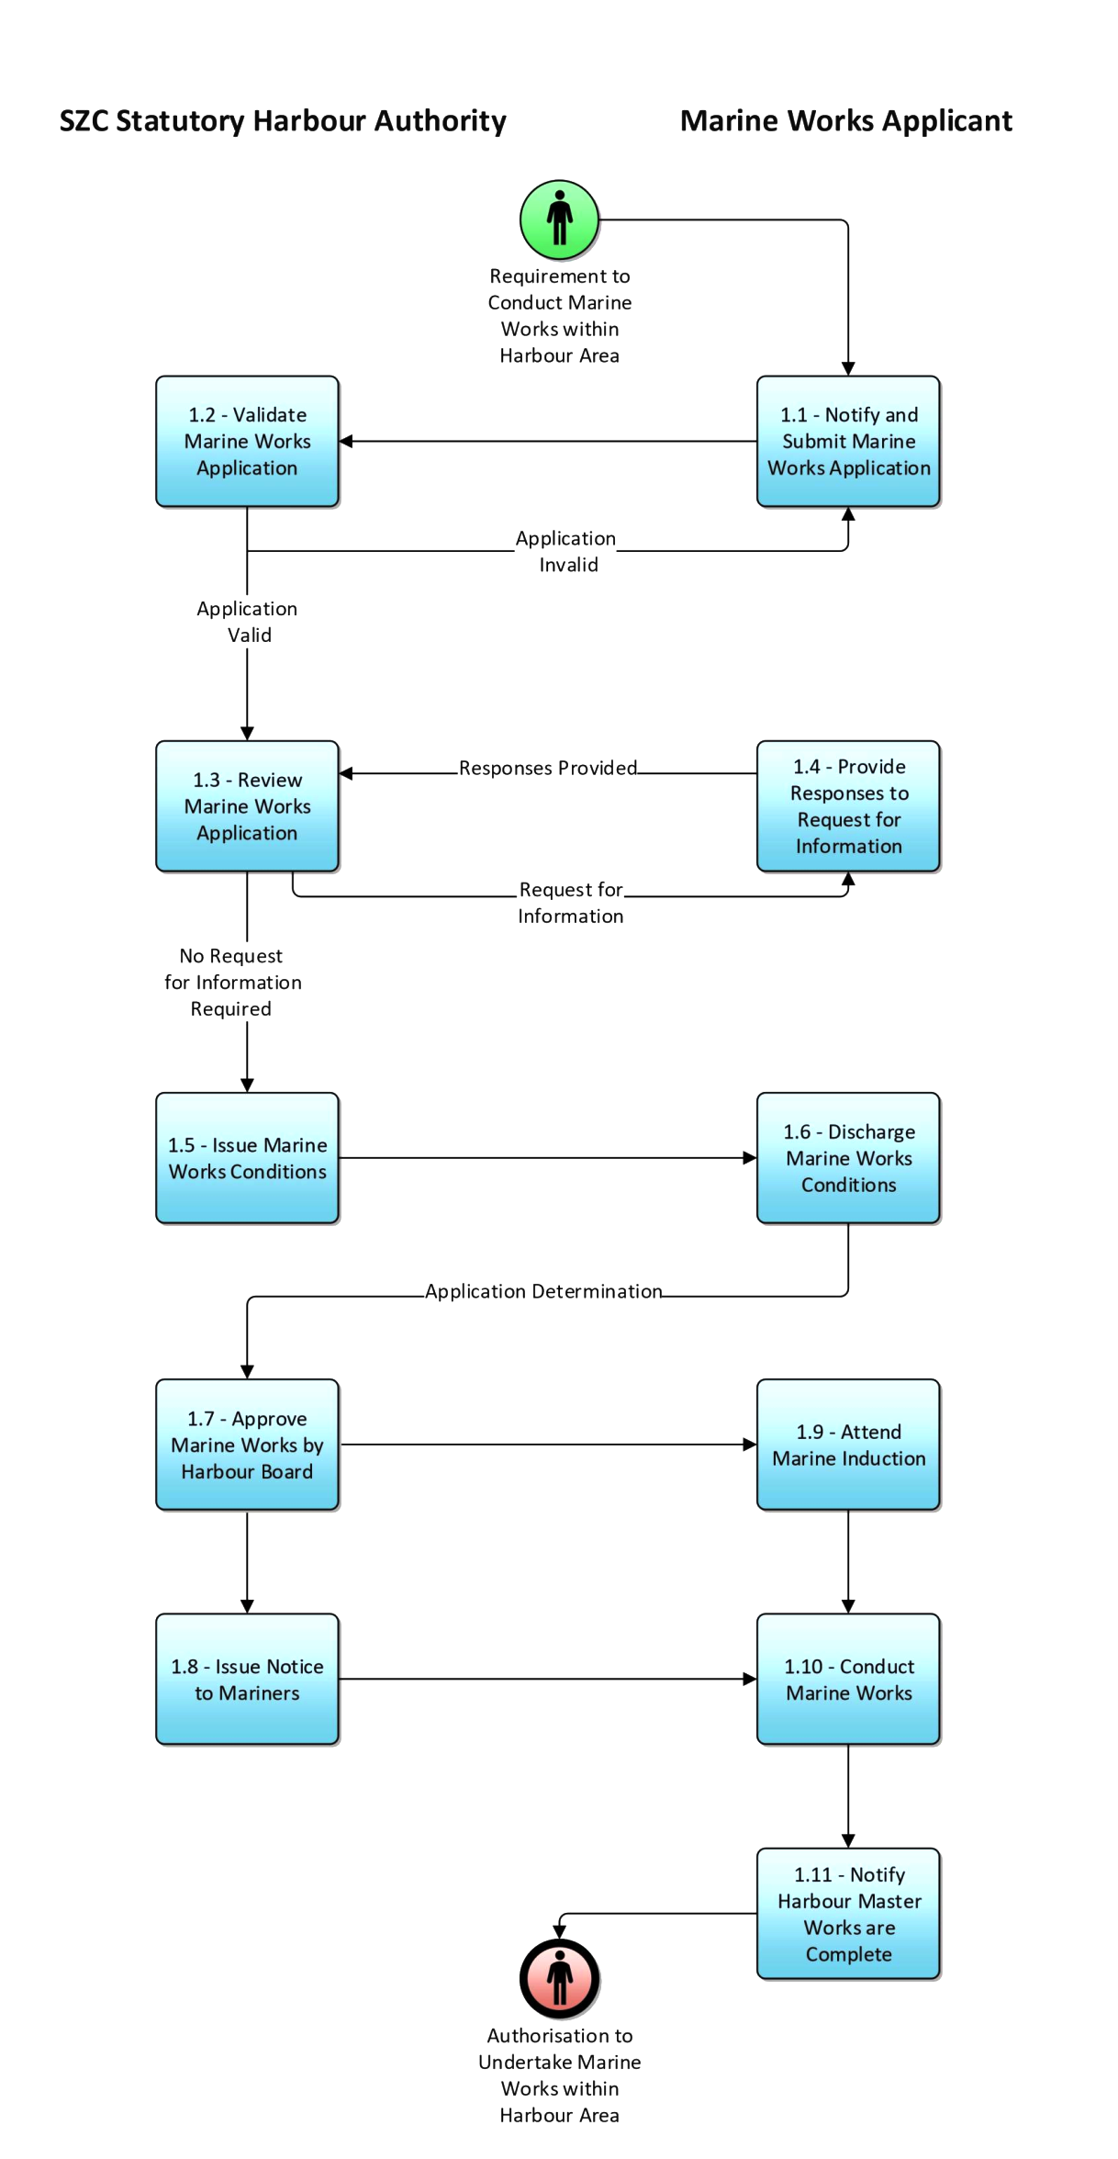

3 INPUTS, OUTPUTS & ACTIVITIES

3.1 Procedure Inputs & Outputs

The input(s) into the Manage Harbour Works Company Procedure are:

Procedure Input Name | Roles that provide this input | Procedures that provide this input
Requirement to Conduct Marine Works within Harbour Area | • Marine Works Applicant | N/A

The output(s) from the Manage Harbour Works Company Procedure are:

Procedure Output Name | Roles that receive this output | Procedures that receive this output
Authorisation to Undertake Marine Works within Harbour Area | • Marine Works Applicant | N/A

3.2 Harbour Works Review and Approval Process

 | Activity | Description | Role
 | 1.1 - Notify and Submit Marine Works Application | Marine Works Applicant requires to complete and submit Marine Works Application along with all the supporting documentation to SZC Harbour Master and Marine Operations Manager.  The process for marine works approval by SZC Harbour Board will be:  - 8 weeks from validation of a completed application where the works are deemed obstructive/intrusive, or  - 4 weeks from validation of a completed application where the works are deemed non-obstructive and have minimal impact on safety of navigation (e.g. surveys, monitoring, etc.)  Note that most marine works will require a marine licence to be issued by the Marine Management Organisation (MMO). SZC Ltd already has a Marine Licence for most of its marine works (it was "Deemed" within the Development Consent Order (DCO) hence Deemed Marine Licence or DML) but all activities require pre-commencement Conditions to be fulfilled. The DML states that all necessary information should be submitted no less than 6 months prior to works commencing. Licensable activities not included in the DML will require a new application to be made. The MMO does not have a statutory time limit for issuing licences but operates to a KPI of approving 90% of applications within 13 weeks. SZC Ltd is a high interest project and longer timescales should be anticipated (e.g. 6 months).  Intertidal works are also under the jurisdiction of East Suffolk Council (ESC) (as far as the Mean Low Water tidal level) and may require planning consent from ESC. For the SZC Project, Requirements 12 and 19 of the DCO apply.  There is also a requirement to have proposed marine works approved by SZB in order to ensure that the infrastructure and operational assets of SZB are appropriately protected from potential impacts from marine operations within the SHA area. For the SZC Project this approval is made via a 'cross-site modification form'. | Marine Works Applicant  (Responsible)
 | 1.2 - Validate Marine Works Application | The Marine Works Application form provides a checklist of additional information which must be submitted with the application to allow it to be registered as a valid marine work application. Failure to submit the required information will render the application invalid, and it will not be registered. The 4 / 8 week period for determination will not begin until the Statutory Harbour Authority has confirmed that the marine works application has been validated.  The list of validation requirements is not exhaustive and the Statutory Harbour Authority reserves the right to request further information post-validation. A valid marine works application may still be refused should necessary further information not be supplied. | SZC Statutory Harbour Authority  (Responsible)
 | 1.3 - Review Marine Works Application | Once a completed Marine Works Application form has been validated, the SZC SHA will review the application. | SZC Statutory Harbour Authority  (Responsible)
 | 1.4 - Provide Responses to Request for Information (RFI) | Further liaison between the SZC SHA and the marine works applicant may be necessary to query or clarify the information provided.  Upon additional Request for Information, the determination period will pause until such time when the marine works applicant provides a response to RFI. | Marine Works Applicant  (Responsible)
 | 1.5 - Issue Marine Works Conditions | SZC Harbour Master will issue any pre-commencement and operational conditions relating to the proposed marine works to the marine works applicant. | SZC Statutory Harbour Authority  (Responsible)
 | 1.6 - Discharge Marine Works Conditions | The marine works applicant must demonstrate that all pre-commencement conditions are discharged ahead of the start of the works and that provisions are in place for implementation of operational conditions.  A mandatory requirement for all vessel masters, barge masters and anyone taking the conn of a vessel is to have a Local Knowledge Endorsement (LKE) approval prior to entering the harbour limits. | Marine Works Applicant  (Responsible)
 | 1.7 - Approve Marine Works by Harbour Board | Where the works are deemed non-obstructive and have minimal impact on safety of navigation, once the Harbour Master is content to approve the marine works, the Harbour Master and Marine Operations Manager will sign the MWA and authorise the works to go ahead.  Where the works are deemed obstructive, or have an impact on safety of navigation, MWA sign off from both the Harbour Master and the Harbour Board will be required.  If the SZC SHA is not content with the marine works and considers that insufficient information has been submitted or that the marine works would adversely affect navigation safety, the application will be refused. The justification for the SZC SHA’s decision will be outlined within the non-approval notice, which will be sent to the applicant.  If the marine works are approved, further conditions or Special Directions may need to be imposed on the applicant in relation to the marine works. These will be communicated to the applicant prior to the commencement of the marine works and will be outlined within the Marine Works Application form. The SZC SHA will send a final copy of this form to the applicant by email before works commence. | SZC Statutory Harbour Authority  (Responsible)
 | 1.8 - Issue Notice to Mariners | Once the marine works have been authorised, the Harbour Master will issue a Notice to Mariners to inform harbour users of the planned marine works and any specific precautions or risk control measures exercised. | SZC Statutory Harbour Authority  (Responsible)
 | 1.9 - Attend Marine Induction | The SZC Harbour Master or Marine Operations Manager will arrange for the marine works applicant and the masters of the vessels undertaking the marine works to receive a marine induction which is designed to ensure that all SZC protocols including Harbour Authority requirements are understood and implemented.  The attendance of a Marine Induction will be a mandatory condition of all marine works applications. | Marine Works Applicant  (Responsible)
 | 1.10 - Conduct Marine Works | The marine works applicant will carry out the approved marine works. | Marine Works Applicant  (Responsible)
 | 1.11 - Notify Harbour Master Works are Complete | Once the works have been completed, the marine works applicant must notify the Harbour Master that the works are complete / de-mobilised and attend a brief online session so that feedback and any lessons learnt are captured. | Marine Works Applicant  (Responsible)

4 SUPPORTING DOCUMENTATION

Marine Works Approval Template | EDRMS | 101453347

5 RECORDS REQUIREMENTS

The following records will be completed:

Title | Category | Location | Reason for Document
Marine Works Application (MWA) & Supporting Documentation stored in MSMS (Digi-SMS) | TBC | EDRMS | Description TBC

6 RESOURCES

This procedure uses the following specific resources:

• | EDRMS

7 PEOPLE

The stakeholders involved in the development of this procedure are:

• Marine Operations Manager

• Harbour Master

8 REQUIREMENTS

This procedure demonstrates how SZC will conform to the Requirements listed below:

Requirement | Regulation Framework
Port and Marine Facilities Safety Code (PMSC) Requirements | Standards & Practice

